An Exemplary Title for an Academic Paper[1]

An Informative Subtitle

July 14, 2023

First Author, $​^{a}$ Second Author, $​^{b}$ and Third Author $​^{c}$

$​^{a}$ Institute, [email@institute.edu](mailto:email@institute.edu)

Institute, [email@institute.edu](mailto:email@institute.edu)

Institute, [email@institute.edu](mailto:email@institute.edu)

Abstract

*[Replace with your abstract]* This project, developed in RStudio and hosted on a GitHub repository, leverages the powerful capabilities of the Bookdown package to produce an academic paper in Microsoft Word format. The template provides a structured framework for composing, compiling, and publishing scholarly works, integrating features such as automatic reference and citation management, seamless inclusion of R code and outputs, versatile formatting, and efficient version control.

# 1 Heading 1

## 1.1 Heading 2

### 1.1.1 Heading 3

#### 1.1.1.1 Heading 4

# 2 Cross Referencing

## 2.1 Figures

See Figure 1.

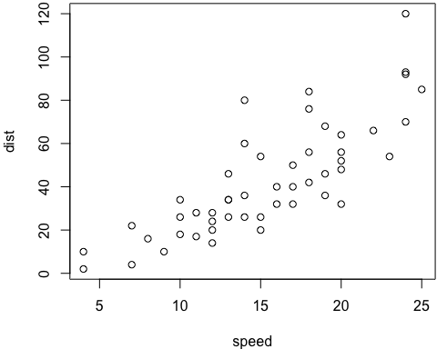

Figure 1: The cars data.

## 2.2 Equations

See Equation (1).

$$\overset{‾}{X}=\frac{\sum_{i=1}^{n}{X_{i}}}{n} \left(1\right)$$

## 2.3 Tables

See Table 1.

Table 1: kable with crossref

|  | mpg | cyl | disp | hp | drat |
| --- | --- | --- | --- | --- | --- |
| Mazda RX4 | 21.0 | 6 | 160 | 110 | 3.90 |
| Mazda RX4 Wag | 21.0 | 6 | 160 | 110 | 3.90 |
| Datsun 710 | 22.8 | 4 | 108 | 93 | 3.85 |
| Hornet 4 Drive | 21.4 | 6 | 258 | 110 | 3.08 |
| Hornet Sportabout | 18.7 | 8 | 360 | 175 | 3.15 |

See Table 2

Table 2: Flextable with crossref

| **mpg** | **cyl** | **disp** | **hp** | **drat** | **wt** | **qsec** | **vs** | **am** | **gear** | **carb** |
| --- | --- | --- | --- | --- | --- | --- | --- | --- | --- | --- |
| 21.0 | 6 | 160 | 110 | 3.90 | 2.620 | 16.46 | 0 | 1 | 4 | 4 |
| 21.0 | 6 | 160 | 110 | 3.90 | 2.875 | 17.02 | 0 | 1 | 4 | 4 |
| 22.8 | 4 | 108 | 93 | 3.85 | 2.320 | 18.61 | 1 | 1 | 4 | 1 |
| 21.4 | 6 | 258 | 110 | 3.08 | 3.215 | 19.44 | 1 | 0 | 3 | 1 |
| 18.7 | 8 | 360 | 175 | 3.15 | 3.440 | 17.02 | 0 | 0 | 3 | 2 |
| 18.1 | 6 | 225 | 105 | 2.76 | 3.460 | 20.22 | 1 | 0 | 3 | 1 |

# 3 Citations

Citation commands: @sampleArticle is is Author (Year), i.e. Smith and Doe (2023), and [@sampleArticle] is (Author Year), i.e. (Smith and Doe 2023).

# References

Doe, Jane. 2022. *Title of the Book*. Publisher.

Smith, John. 2023. “Title of the Conference Paper.” In *Name of the Conference*, 12–15. Organizer.

Smith, John, and Jane Doe. 2023. “Title of the Article.” *Name of the Journal* 7 (2): 123–26.

1. Thanks